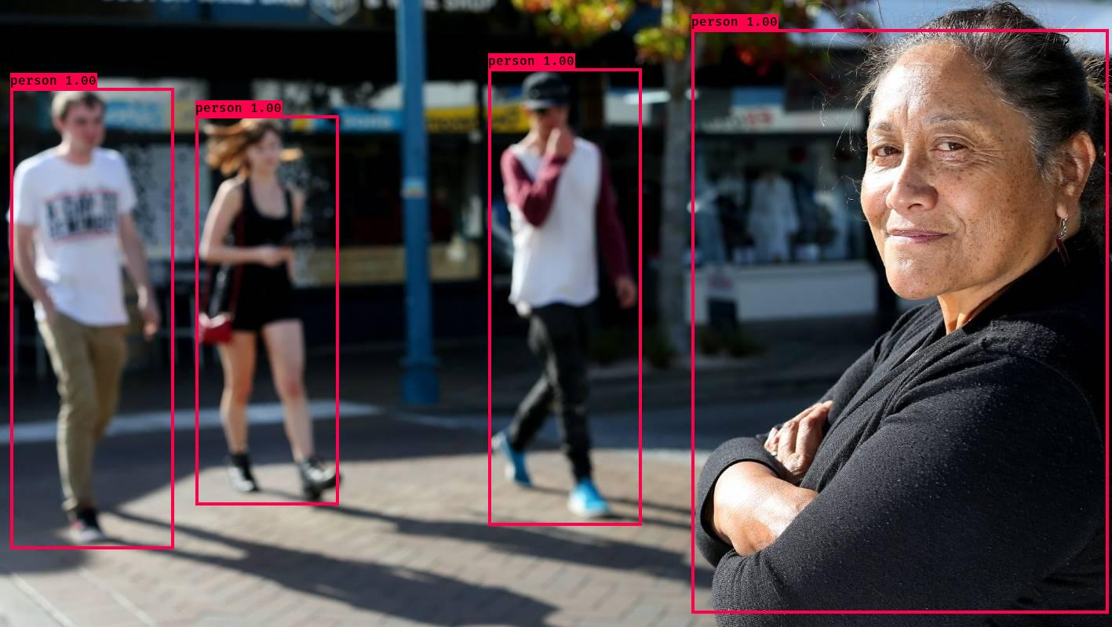

YOLOv3-IoU is a deep learning algorithm. It used for pedestrian detection and object detection. It is based on You Only Look Once (YOLO) algorithm and the improved Intersection over Union (IoU) loss function.

Breast Cancer classification is trained Convolutional Neural Networks model, classify benign and malignant breast cancer tumors by histopathological Image. It applied Residual Neural Network to avoid vanishing gradient problem during many hidden layers. In the end, it reached **95.9%** accuracy by Linear SVM Classifier.

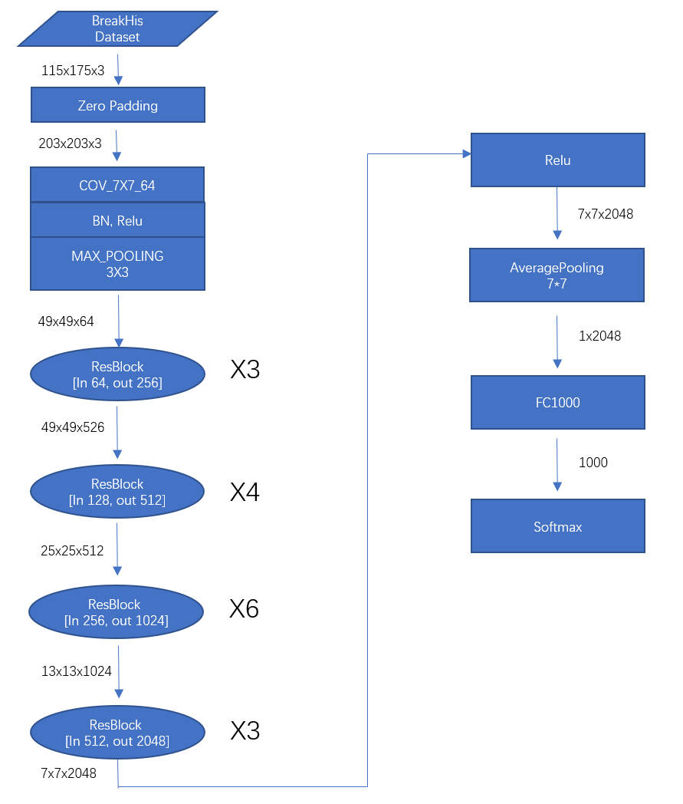

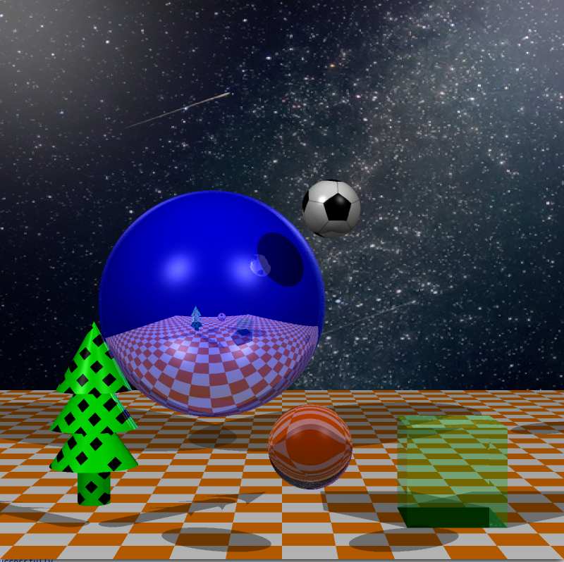

Ray Tracer can achieve lighting, shadows, and reflections of multiple types of geometric objects. It has more challenging requirements than Invading aliens and base because it requires many mathematical equations to achieve some effect, such as transparent objects, refraction, anti-aliasing, and procedural textures.

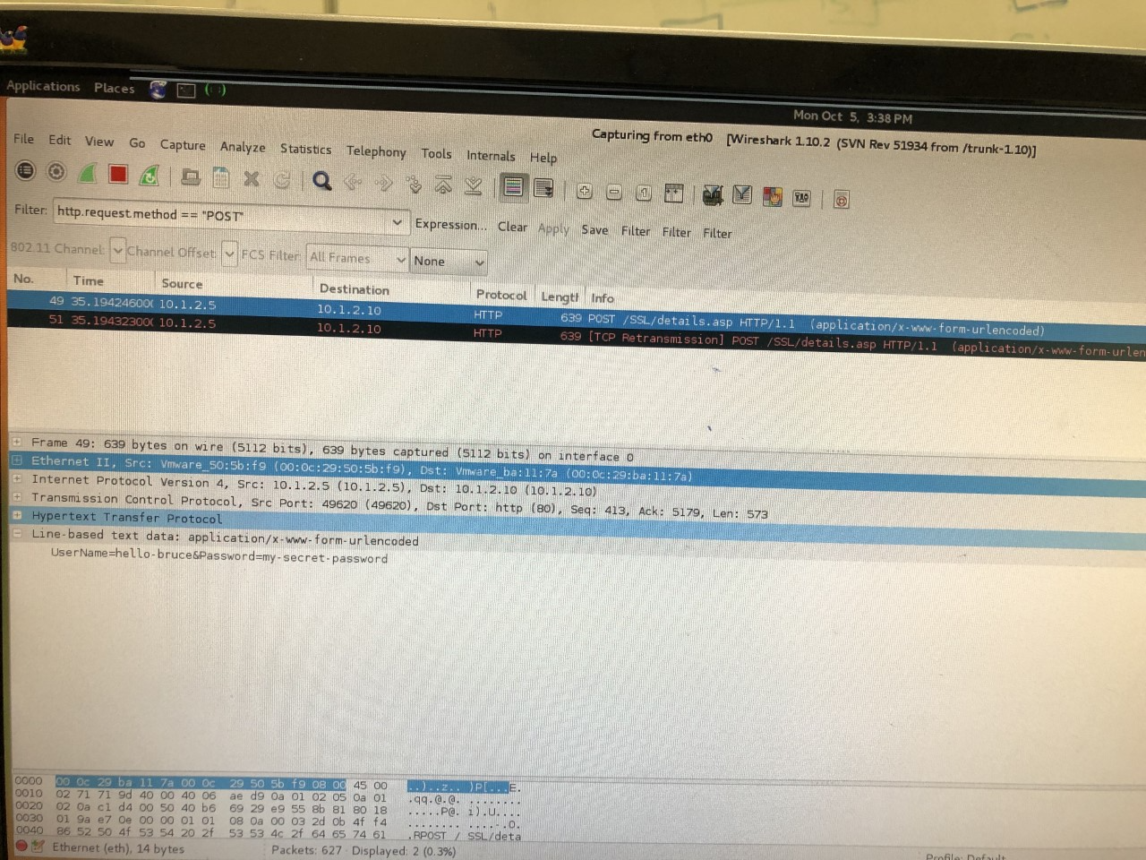

Man-in-the-Middle (MITM) attacks are a common attack method used by attackers and can cause serious consequences. Therefore, we simulated the experiment of MITM attacks intercepting HTTP and HTTPS traffic. The MITM in the experiment used ARP Spoofing to redirect the sending packet to a wrong address to achieve the purpose of interception. The tool we used when intercepting HTTP traffic is Ettercap.

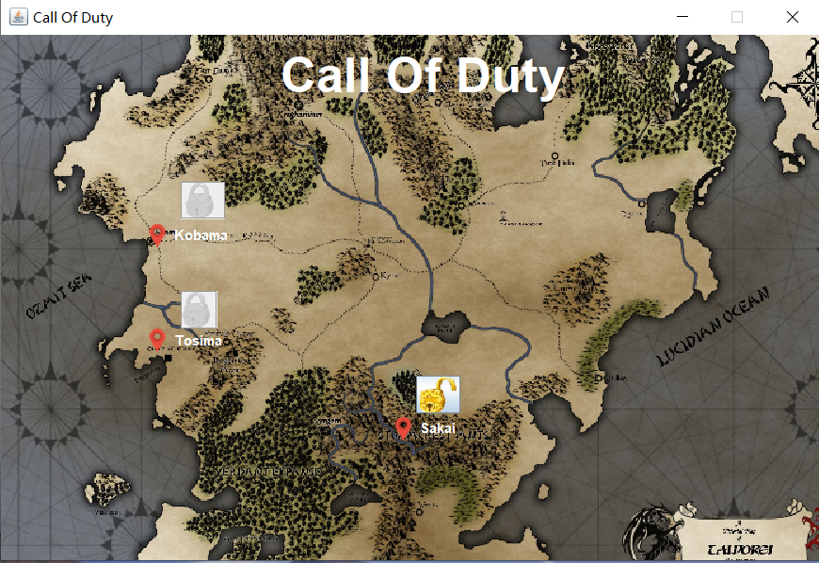

Heroes and Villains is a Java game application with cache, developed in Swing. The player can create a hero team with different attributes, the player is able to go to north, south, east, or west, the different direction represents a place, for example, hospital helps heroes to recover health, villains lair has villains to fight.

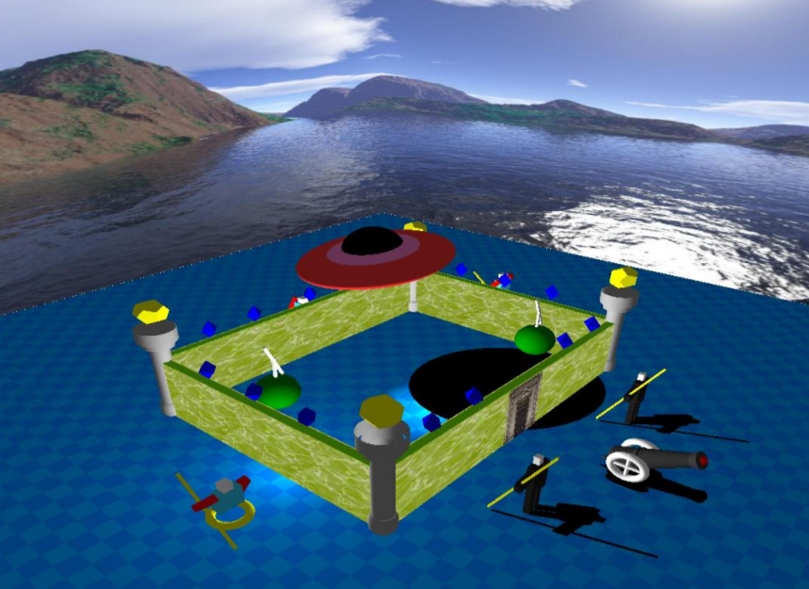

Invading aliens and base is a computer graphics project implemented by OpenGL. The design based on invading aliens and their base. There are some interesting parts inside the base, energy diamond, UFO, aliens, and cannons, etc.